Research/Review Article

Title of the Paper (16 point, Bold, Times New Roman)
First Author’s Name¹, Second Author’s Name^{2*} , Third Author’s Name³, …….
¹ Affiliation (Department, Faculty/College, Institution/University, Country)
^{2, 3} Affiliation of other authors, if different (Department, Faculty/College, Institution/University, Country)
Email¹, Email²
*Corresponding author: Name and email
ABSTRACT
The manuscript should contain a self-contained abstract of up to 300 words without citations. It must succinctly present the research's purpose, methodology, key findings, and main conclusions. The abstract should be a single, continuous paragraph without subheadings or bullet points. Moreover, non-standard, or uncommon abbreviations should be avoided, but if essential, they must be defined at their first occurrence in the abstract.
Keywords: Provide 5-8 relevant keywords, separated by comma, for indexing purpose.
- Introduction
The introduction typically starts a research paper, providing a brief overview of the work, the need for the study, the problem statement, and the authors' contributions. It should include sufficient recent citations [1] from the past a few years to highlight existing challenges and the significance of the research. This section should be concise, without subheadings unless necessary [2, 3]. Clearly state the research objectives and provide relevant background information while avoiding an extensive literature review or a summary of the results.
- Research Methodology
This section should provide sufficient detail to allow the reproduction of the reported data. If multiple methods are described, it can be divided into subsections. Previously published methods should be cited [4], with only relevant modifications explained. The methodology should be written concisely while maintaining textual continuity.
- Theory and Calculation
Theory section should build upon, rather than repeat, the background provided in the Introduction, forming the basis for further research. In contrast, the Calculation section should focus on practical developments derived from the theoretical framework. Avoid including extensive basic definitions or well-known theories; instead, emphasize the theoretical background and its specific applications relevant to your work.
  - Mathematical Expressions and Symbols
Mathematical formulas and symbols must be inserted using Microsoft Word’s equation tool. To support the validity of the equations, appropriate references can be included, such as "this result was produced using Artificial Neural Network [5]."
$f\left(x\right)=a_{0}+\sum_{n=1}^{∞}{\left(a_{n}\cos{\frac{nπx}{L}}+b_{n}\sin{\frac{nπx}{L}}\right)}$ (1)

- Results and Discussion
This section can either be divided into subheadings or presented as a combined Results and Discussion section, which is often suitable. It should focus on the significance of the findings without repeating the results. Instead of an extensive review of the literature, emphasize recent studies to compare your work, highlighting its novelty considering current developments and challenges in the field.
- Preparation of Figures and Tables
Authors are required to insert all figures and tables at the relevant locations within the manuscript. Each figure and table must be properly numbered and accompanied by a descriptive title. It is essential to refer to each figure and table within the text using its corresponding number. Any figure or table that is not explained or numbered may lead to the rejection of the paper.
- Formatting Tables
Tables should be created using the table tool in Microsoft Word and referenced in order throughout the text. Each table must have a descriptive title, and if it includes numerical values, the units should be specified in the column headings. Table 1 summarizes the formatting requirements of the manuscript.
Table 1: Summary of formatting requirement for submitting paper.
Layout | Size | Margin (Normal) | Header | Footer
Single column | A4 (8.27” X 11.69”) | Top=1”  Bottom=1”  Left=1”  Right=1” | Do not add anything in the header | Do not add anything in the footer
Font | Article Title | Abstract | Heading/ Subheadings | Reference list | Text
 | Times New Roman, 16 pt, Bold, centred | Times New Roman, 10 pt, Justified | Times New Roman, 11 pt, Bold, Left aligned | Times New Roman, 10 pt, Justified | Times New Roman, 11 pt, Justified
Line Spacing | 1 | 1 | 1 | 1 | 1
Page number | Publisher will format and assign page numbers
  - Formatting Figures
All figures must be cited in the paper. Figures should be in bitmap formats (TIFF, GIF, JPEG, etc.) with a minimum resolution of 300 dpi, unless a lower resolution is intentionally used for scientific purposes. For example, Figure 1 shows the bar chart comparing the accuracy of Random Forest, SVM, and Neural Networks in predicting CO2 levels and temperature changes.
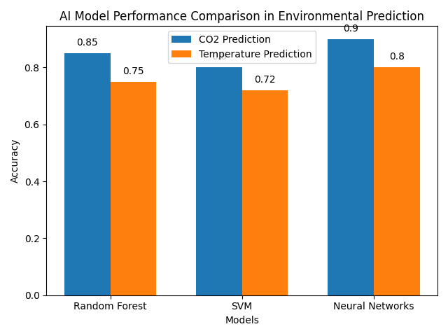
Figure 1: Bar chart comparing the accuracy of Random Forest, SVM, and Neural Networks in predicting CO2 levels and temperature changes.
- Conclusions
The conclusion section should be between 250 and 450 words, summarizing the key findings of the study while emphasizing its significance, limitations, relevance, applications, and recommendations. It should be written in a continuous format, using full sentences, and include the main outcomes of the research, its practical implications, limitations, and suggestions for future work. The conclusion must not include subheadings, citations, references to other sections of the manuscript, or bullet points.
Acknowledgements
Any acknowledgments, if present, should be included in a separate section prior to the references and may mention individuals who contributed to the work but are not listed as authors.
Funding source
Please provide the funding source and any supporting grants along with their respective grant numbers. The names of funding agencies should be spelled out in full. If no funding source is available, please indicate "None."
Conflict of Interest
Declare any potential conflict of interest if exist in this publication.
References
It is the responsibility of the author(s) to ensure that the information in each reference is accurate and complete. References from unreliable websites, news portals, social media, and Wikipedia, should be avoided. Only scholarly sources (journals, online books, conference proceedings, patents, and reputable websites with permanent archival policies) are acceptable. Authors should include enough recent references in the article. All references must be numbered consecutively, and in-text citations should be marked with numbers in square brackets (e.g., “as explained by ABC et al. [1]”; “as discussed in several machine learning-based methods [2]-[6]”). References must be correctly cited within the text; do not provide a reference list without in-text citations. All cited references should be listed in the specified format:
- Goswami, D., & KHAN, M. N. I. (2025). Cybercrime and contractual liability: A systematic review of legal precedents and risk mitigation frameworks. Journal of Sustainable Development and Policy, 1(01), 10-63125.
- Nawala, S., Awaliah, N., & Zulkifli, M. A. (2026, June). A Socio-Legal Analysis of Netizen’s Legal Culture in the Phenomenon of Digital Vigilantism as A Challenge to Cyber Law Enforcement. In Proceedings of Annual Conference on Scientific Writing (Vol. 3, pp. 189-205).
- Lukings, M. K., Habibi Lashkari, A., & Hakimian, P. (2026). Cybercrime Prevention Techniques & Comprehensive Cyber Crime Victim Service Package Proposal. In Understanding Cybercrime Victim Services: Challenges, Risks, Strategies, and Trends (pp. 155-176). Cham: Springer Nature Switzerland.

Note: If a reference manager (e.g., Mendeley, or Endnote) is used, the IEEE citation style with the URL option may be selected.

